- September's downside surprise for UK inflation caused an abrupt turnaround in market pricing this week. Some of the drivers behind the weaker data should reverse, but there were also signs of a genuine cooling in underlying price pressures. We think another rate cut in November remains unlikely, but December is clearly now a live meeting for the Monetary Policy Committee.
- Even if the Office for Budget Responsibility include recent changes in market pricing in its upcoming forecast, it won't be a game changer for the Chancellor. We expect that the government will have to tighten policy by £20bn-£25bn to restore its headroom. And further tightening could be required if the OBR judges that tax receipts underperformance will persist.
The final inflation release before the November Monetary Policy Committee meeting triggered a dovish reaction from financial markets. A November rate cut has looked an unlikely prospect for some time now, but whether the MPC cuts Bank Rate again in December or waits until the February meeting next year has become a more live debate. At the end of last week, market pricing implied there was a 38% chance of a further 25bps cut by the December meeting. By Thursday, that probability had risen to 69%.
September's CPI reading was unchanged at 3.8%, 0.2ppts below the Bank of England's forecast and consensus expectations. The undershoot was largely due to two factors. First, there was an unusually weak reading for food prices, with the Office for National Statistics suggesting that this partly resulted from greater sales and discounting efforts (Chart 1). Second, last year saw the largest September fall in air fares since 2001, so some upward pressure from a smaller monthly fall this year was anticipated. But in the event, September's monthly drop this year was almost as large, which helped services inflation to remain at 4.7%.
Though some of the factors that contributed to September's downside surprise are likely to unwind in the near term, markets reacted strongly in part because food price inflation is running 0.5ppts below the Bank of England's most recent staff forecast. This should help to soothe some of the MPC's recent worries that high inflation in salient categories, such as food prices, might push up inflation expectations among households and firms, and lead to additional inflation persistence.
Chart 1: September's monthly reading for food prices was well below recent outturns and past norms
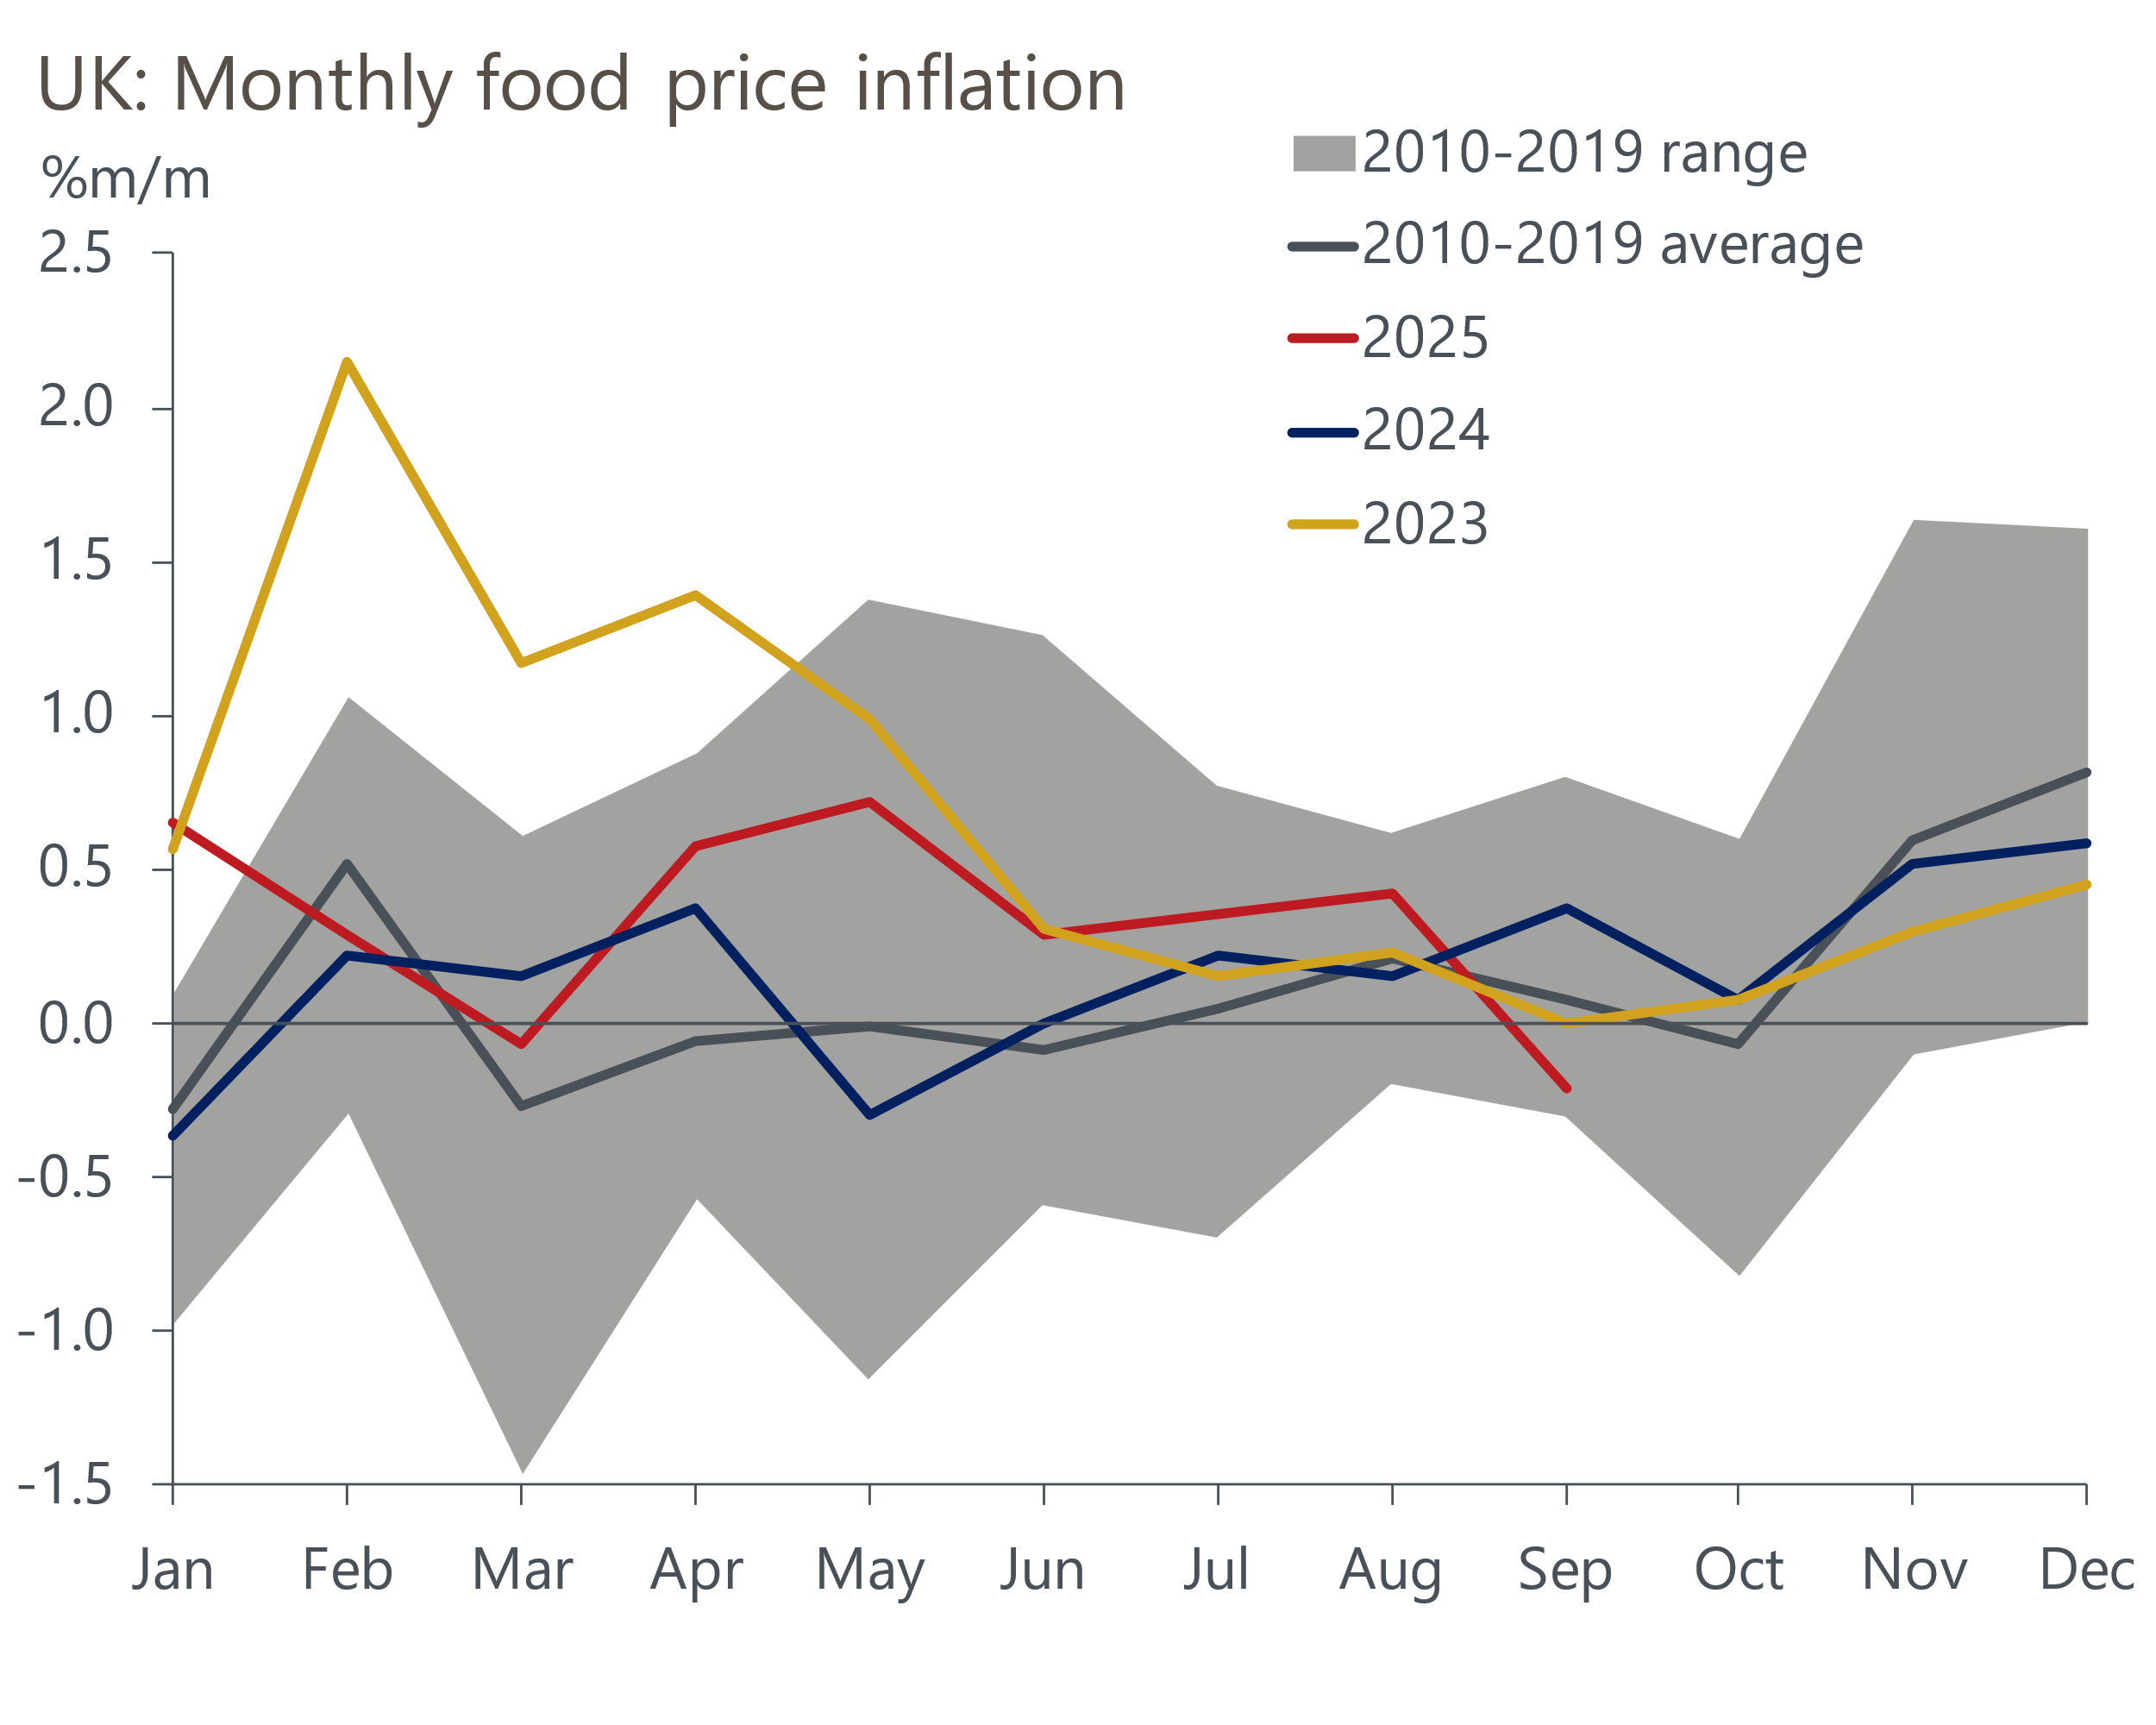
Source: Oxford Economics calculations using data from Haver Analytics

The dovish repricing also reflected that the MPC's concerns about the lack of passthrough of weaker pay growth to services prices will have been helped by services inflation remaining well below the 5% forecast by BoE staff in August's Monetary Policy Report. Indeed, the detail also showed that the MPC's preferred measure of underlying price pressures, which strips out indexed and volatile components, rent, and foreign holidays from services inflation, fell 0.3ppts to 3.9% in September.
On balance, we're sceptical that this week's weaker-than-expected inflation print will be enough to convince a majority of MPC members to vote for looser policy in November. But with the committee having little faith in its inflation forecast, the chances of a December cut have increased.
We should get some steer on how the MPC views the balance of risks further ahead at its meeting in two weeks' time. For now, we continue to expect rate cuts to resume in early 2026. Whether the committee delivers a cut in December, or waits until the February meeting, will likely depend on the contents of the upcoming Budget on November 26 and if the two labour market and inflation releases published before the December meeting deliver material dovish surprises.
With markets moving to price a slightly more benign inflation outlook and a greater chance of a December cut than was previously thought, gilt yields shifted downwards across the entire curve (Chart 2). But whether the fall in borrowing costs over the past week will offer Chancellor Rachel Reeves some reprieve as she gears up to tighten fiscal policy further next month remains unclear.
Chart 2: Gilt yields and market expectations for Bank Rate shifted down this week
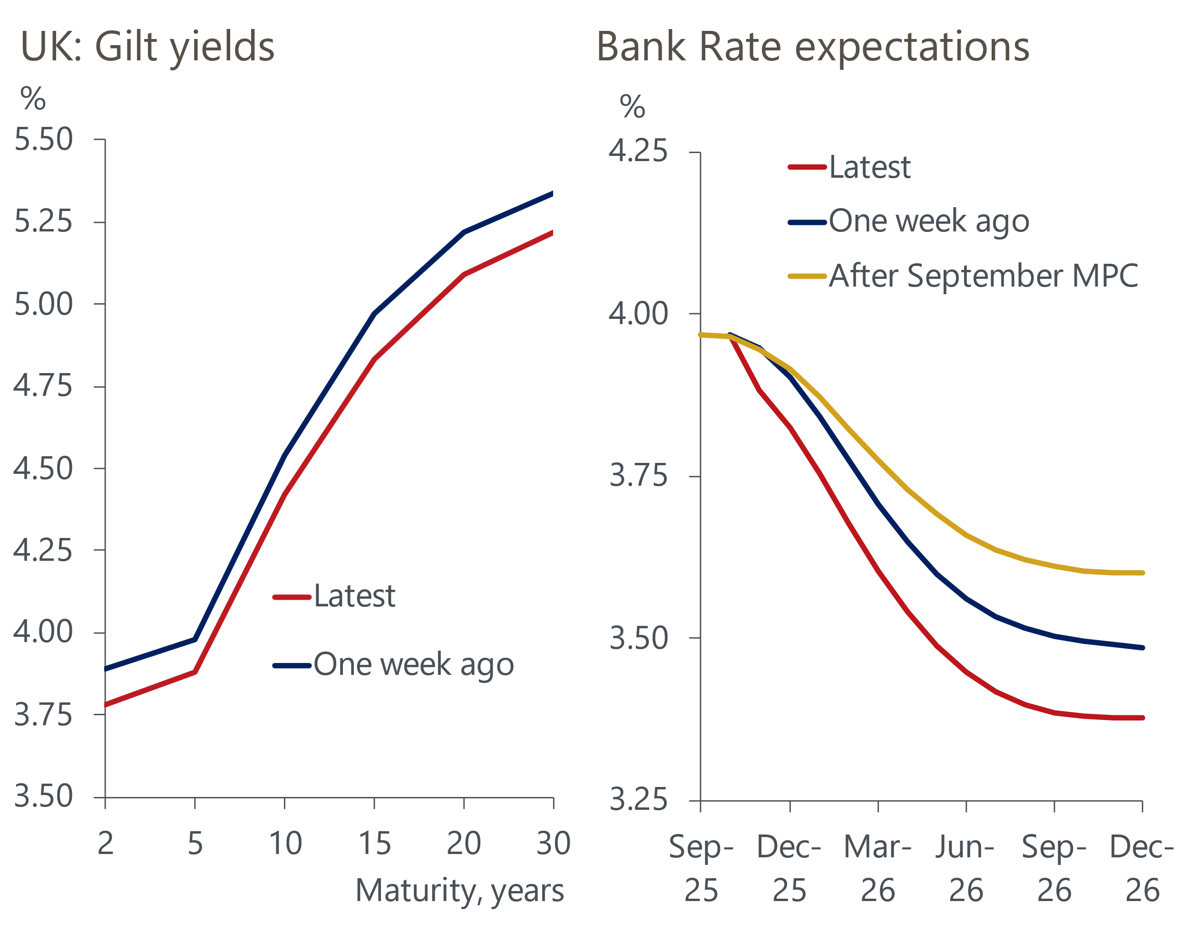
Source: Haver Analytics
If the Office for Budget Responsibility closed its 10 working-day window for collecting financial market data this week after the inflation release, the increase in debt interest costs for the Chancellor would be around £2bn smaller than if the OBR followed its standard approach of closing the window about 30 working days before the Budget – which suggests the 10-day period ended between October 9 and October 15.
The OBR has said that it will not confirm the dates used for the borrowing forecast "for at least a few weeks", and when questioned by Bloomberg, remarked that it would "remain flexible in case we are required to think again". Though the prospect of a smaller increase in debt servicing costs would be welcomed by the Chancellor, the potential savings are unlikely to alter the fiscal arithmetic significantly. We expect that the government will have to tighten policy by £20bn-£25bn to restore its thin fiscal headroom.
Additional tightening would be required if the Chancellor chooses to increase her headroom. A further uncertainty is whether the OBR will assume that the weak performance of tax receipts this year carries forward into future years. Indeed, this week's public sector finance data for September showed that after favourable revisions to account for a recent error in VAT estimates, the current budget deficit reached £71.8bn over the first half of this fiscal year, £13bn higher than forecast by the OBR in the spring. We have already outlined what we expect the Chancellor to deliver at the autumn Budget, but in a forthcoming Research Briefing we plan to switch gears and give our take on what the government should do to address the UK's fiscal vulnerabilities.

The week ahead
Next week should prove much quieter, with the Bank of England's Money & Credit data for September the only major release of note. After a slightly weaker print in August, we expect only a small increase in mortgage approvals to 65,200 in September, from 64,700 in August, with a modest rise in quoted mortgage rates during the month and pre-Budget jitters weighing on the rebound in demand.
But the data on lending flows should be firmer because of the lag between a mortgage being approved and the funds being dispensed. We forecast that net mortgage lending inched up to £4.4bn in September, from £4.3bn in August, because the pickup in approvals through most of the summer should have translated into stronger gross lending flows in September.
On the unsecured side, August's outturn for net lending was flat, as an increase in gross lending was completely offset by a pickup in repayments. Though there's scope for the rise in repayments to unwind, we suspect gross lending is likely to have fallen back to a greater extent. Therefore, we think net unsecured lending fell to £1.2bn in September, from £1.7bn in August.
Table 1: Week ahead calendar
Date | Events | Period | Measure | Unit | Previous | Forecast
Oct 29 | Mortgage approvals | Sep | Level | 000s | 64.7 | 65.2
Oct 29 | Mortgage lending | Sep | Net lending | £bn | 4.3 | 4.4
Oct 29 | Consumer credit | Sep | Net lending | £bn | 1.7 | 1.2
Oct 31 | Nationwide house prices | Oct | m/m | % | -0.3 | 0.1
Oct 31 | Nationwide house prices | Oct | y/y | % | 1.3 | 1.4
Source: Oxford Economics

Key forecasts
Table 2: UK forecast overview
(Annual percentage changes unless specified)
 | 2023 | 2024 | 2025 | 2026 | 2027 | 2028
GDP | 0.3 | 1.1 | 1.5 | 0.9 | 1.3 | 1.7
Private consumption | -0.3 | -0.2 | 1.0 | 1.1 | 1.1 | 1.7
Fixed investment | 0.5 | 1.8 | 2.1 | 0.5 | 1.5 | 2.0
Government consumption | 2.1 | 3.4 | 2.1 | 1.7 | 1.6 | 1.7
Exports of goods and services | -2.3 | 0.6 | 3.0 | 0.2 | 1.2 | 1.5
Imports of goods and services | -1.6 | 2.6 | 3.9 | -0.5 | 1.2 | 1.5
Industrial production | -2.6 | -1.6 | -0.3 | -0.1 | 1.1 | 1.4
Consumer prices | 7.3 | 2.5 | 3.5 | 2.8 | 2.5 | 2.2
Unemployment rate (%) | 4.1 | 4.3 | 4.7 | 4.9 | 4.8 | 4.4
Current a/c balance (% of GDP) | -3.6 | -2.2 | -3.1 | -2.6 | -2.4 | -2.3
Government balance (% of GDP) | 5.2 | 5.1 | 4.6 | 3.7 | 3.1 | 2.7
Central bank policy rate (%, EOP) | 5.25 | 4.75 | 4.00 | 3.50 | 3.00 | 2.75
10yr govt. bond yield (%, EOP) | 3.54 | 4.57 | 4.70 | 4.28 | 3.80 | 3.51
Exchange rate (US$ per £, EOP) | 1.27 | 1.25 | 1.34 | 1.34 | 1.34 | 1.34
Exchange rate (euro per £, EOP) | 1.15 | 1.21 | 1.15 | 1.15 | 1.15 | 1.15
Source: Oxford Economics
Table 3: Quarterly forecasts for the UK
 | 2025 |  |  |  | 2026
 | Q1 | Q2 | Q3 | Q4 | Q1 | Q2 | Q3 | Q4
GDP (% year) | 1.7 | 1.4 | 1.4 | 1.3 | 0.9 | 0.9 | 0.9 | 1.0
CPI inflation (% year) | 2.8 | 3.5 | 3.9 | 3.7 | 3.4 | 2.6 | 2.6 | 2.6
Bank Rate (%, EOP) | 4.50 | 4.25 | 4.00 | 4.00 | 3.75 | 3.75 | 3.50 | 3.50
10yr gilt yield (%, EOP) | 4.70 | 4.48 | 4.70 | 4.70 | 4.69 | 4.58 | 4.44 | 4.28
US$ per £ (EOP) | 1.29 | 1.37 | 1.35 | 1.34 | 1.34 | 1.34 | 1.34 | 1.34
Euro per £ (EOP) | 1.20 | 1.17 | 1.15 | 1.15 | 1.15 | 1.15 | 1.15 | 1.15
Source: Oxford Economics

Latest Country Economic Forecast:
October 13, 2025

Recent publications

Data Insights
PMI points to soft pre-Budget growth
Retail sales surged again in September
Inflation surprised to the downside in September
Public finances remain fragile in the run up to the Budget
GDP grew modestly in August, but the outlook remains subdued

Research Briefings
What happens if markets lose faith in the fiscal approach?
What will the Chancellor do in the Budget?
Fiscal fragility could reveal sterling's vulnerability
MPC follows path of least resistance on quantitative tightening
MPC preview – Pace and shape of QT is likely to be tweaked

Contacts

Oxford Economics' UK team
- Andrew Goodwin - Chief UK Economist - agoodwin@oxfordeconomics.com
- Edward Allenby - Senior UK Economist - eallenby@oxfordeconomics.com

